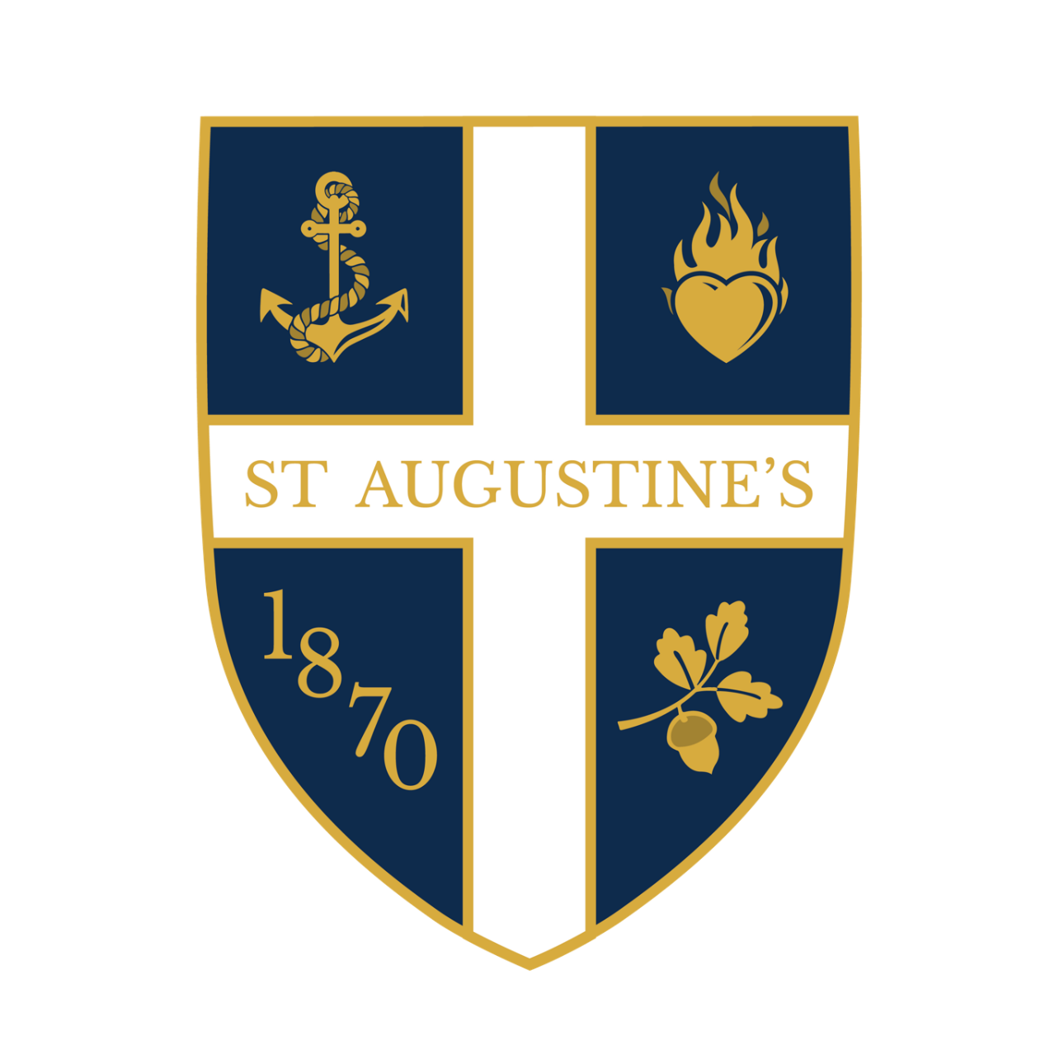


ST AUGUSTINE’S CE HIGH SCHOOL
SUBJECT OFFERS
2026-2027
SIXTH FORM

Pathways
A-levels | Vocational
A-Levels are academic, advances qualifications that provide in-depth expertise on a certain subject | A BTEC/CTEC is a vocational qualification. This means it is related to a particular job or career sector
Progression to Uni  A-levels provide a clear pathway to university education. The grades achieved in A-level exams are often used by universities as a key factor in their admission decisions. | Limited Exams  Btec/Ctec are coursework focussed which means that, depending on your course means that you do not have to do many exams HOWEVER there are far more deadlines for completion of work.
Lots of Choice  The range of subjects available at A-level is wide an varied meaning that you can choose subjects that align with your interest and career aspirations | Try Again (if needed)  Unlike A-levels where a large chunk of your final grade is assessed by exams, BTECS/CTECS allow you to resubmit a piece of coursework so that you can get the best possible grade
Go abroad!  ‘A’ Level is a ‘gold standard’ qualification. They are internationally recognised and offer the flexibility of going abroad to study afterwards. | Progression to Uni  BTEC/CTEC can be an excellent way to progress into university and most universities accept this qualification including Russel Group Universities
More than one  You can study 3-4 A-levels, this allows you to tailor your studies to your individual strengths and interests. This is also perfect for those who want options. | Career Focused  BTEC/CTEC can give you a range of employability skills. It is possible to walk straight into a job after finishing Sixth Form especially if you have applied to the industry your BTEC/CTEC is focussed on.
In depth Study  A-levels are advanced qualifications that explore a subject in detail. This is perfect for you if you want to become a subject expert. | Employer valued  As they are career focussed it is also statistically shown that employers value them too. This is mainly due to the fact that they provide real world skills

St Augustine’s Sixth Form Centre
10 Reasons to join us!

- Excellent Sixth Form Teaching
- Fantastic work-related opportunities and support
- Extra - curricular activities
- Student Leadership opportunities to make a difference, lead, mentor & be a role model to your peers and younger students
- Independence & Responsibility
- Dedicated Sixth Form Team to support all your academic and pastoral needs
- Sixth Form dedicated areas
- Computer suite for Sixth Form Students only
- Trips, adventures and experiences
- Individual & personalised UCAS and Apprenticeship support

Choosing your Subjects!

When choosing you subjects, you should consider what you enjoy and way you are good at; the combination of subjects for your chosen career or degree and whether your predicted grades qualify you to study those subjects. The broad range of subjects we offer is designed to deliver a personalised programme of study, delivering excellent standard of learning and teaching, enabling greater support and ultimately successful outcomes for your future. This means that you can combine both A-Level and Vocational courses.

St Augustine’s Sixth Form Entry Requirements
This allows you to be eligible for St Augustine’ however does not guarantee places on a particular subject

Minimum Entry Requirement
Five x Grade 5 (including Maths and English)

Subject Entry Grades
Range between Grade 5-8 depending on subject.

Application Process
- Open Evening
- Apply on-line
- Interview
- GCSE Enrolment

Art&Design-Fine Art

Why Study Fine Art at A-LEVEL?


A level Art allows you to develop an exciting and extensive range of creative and technical skills. You will also gain a strong understanding of historic and contemporary visual art practice, through supporting contextual studies. Unique to studying Art at A Level, you build up a very personal and continually evolving body of practical work, guided and supported by your teachers. Individual exploration and development of your personal skills and creative directions is a special aspect of this subject.

Course Content

Exactly like GCSE Art the course is broken down into two components, coursework which is 60% of your art studies and an externally set assignment which is 40%.

Year 12
Component 1
Foundation Project
Culture & Society
The Word Theme
Personal Investigation
Year 13
Personal Investigation continued
Component 2
Externally Set Assignment
Topics covered can include:

Our A level Art courses introduce you to a wide range of media and processes. These will always include drawing, whatever specialism you choose, but can also include a range of other techniques and processes: painting, printmaking, collage, photography, digital work, mixed media, sculpture, film and performance. The area you spend most time on will depend on the direction and focus of your chosen specialism. You will develop an extensive range of creative practical work, with some supporting 'contextual skills'.

What other subjects go well with this subject?

English Literature, Politics, Ethics, Philosophy & Religion, Geography, History, Philosophy, Psychology, and Sociology.

Career Pathway

A level Art students can go on to study on a range of Art & Design foundation and degree courses, nationally and internationally, and train in their area of specialisation, before going on to become an artists, designers, architects, or arts professional in a broad variety of specialist areas. The creative and cultural arts industries express and reflect the importance of creativity and culture in our society. All around us artists create the world we inhabit and contribute to a thriving and important industry which has a vast range of exciting career options and choices. These can include working in Fine Art, Fashion Design, Illustration, Graphic Design, Interior Design or Architecture, for example, as well as many other possible creative art & design jobs and careers.

Exam Board

AQA

Entry Requirements

Grade 5 at GCSE Fine Art or Graphics & Grade 5 (English Language/Literature)
Grade 5 depending on department approval

Cultural Capital Opportunities (Trips, guest speakers, wider enrichment & more)
Whitechapel Galleries, Tate Modern, National Gallery, Photographers’ Gallery EPQ, UAL Insights programme, visiting artists & workshops; opportunities to run our Art & Fashion Clubs in school & develop your leadership skills.

AAQ Applied Science


Why Study Applied Science?

Applied Science offers an exciting way to deepen your understanding of Biology, Chemistry and Physics — not just in theory, but in hands-on, real-world contexts. If you enjoy experimenting, solving problems, and making sense of how scientific ideas work in practice (from health issues to energy, environmental change to new technologies), this course gives you the chance to build those skills. It is equivalent to one A Level, so it complements other A Levels nicely. It’s particularly useful if you are considering science-based degrees (e.g. Biomedical Science, Forensic Science, Environmental Science, Health Professions) or technical careers in laboratory work, research, healthcare, engineering or industry. Alongside scientific knowledge, you’ll develop important transferable skills such as data analysis, critical thinking, report writing, practical experiment skills, and scientific literacy.

Course Content

Students engage with all three sciences: Biology, Chemistry, and Physics, exploring topics such as fundamental chemical and physical principles, cell structure and function, physiology and disease, and electromagnetic waves, along with many other exciting areas of modern science.

Topics covered can include:

The Applied Science Extended Certificate covers the essential areas of Biology, Chemistry and Physics, including cells and tissues, chemical bonding and reactions, waves, energy and motion. Students also develop practical laboratory skills through scientific procedures and techniques such as chromatography, colorimetry and accurate quantitative measurements. Optional units allow exploration of Scientific Investigation Skills or Contemporary Issues in Science, giving students the opportunity to plan experiments, analyse data, and evaluate how science addresses real-world challenges. Assessment combines exams, coursework and practical tasks, ensuring a strong balance of theoretical knowledge and applied scientific skills.

What other subjects go well with this subject?

Applied Science complements various science A-levels, including Psychology, Maths, IT, Sociology and Sport.

Career Pathway

Graduates can transition directly into employment, pursue apprenticeships, or continue to a wide range of science-based degree courses, such as Pharmacy, Biomedical Science, Sports Therapy, Paramedic Science, Radiography, Biological Life Sciences, Nursing, Veterinary Nursing, and Applied Chemistry.

Exam Board

Edexcel (Pearson)
Entry Requirements

Grade 5 at GCSE (English language, Maths and Science)

Cultural Capital Opportunities (Trips, guest speakers, wider enrichment & more)

Kew Gardens fieldwork and coursework. Helping younger students with Science.

Biology

Why study Biology?


Biology is a fascinating subject, the study of which will see you learn about the natural world and all the living things within it. Gaining an A-level in this subject opens up a vast range of opportunities for both university degrees and career options, many of which can take you all around the world.

Students choose Biology for a number of reasons — perhaps they have a specific that requires a Biology qualification in mind, or maybe they are simply interested in the human body, or in the natural world around us. Biology covers a broad range of topics and has aspects to interest a wide range of students. Biology is a pre-requisite subject for many degrees in Biological Science and Medical related fields of study.

Biology is one of the Russell Group universities' 'facilitating' subjects — so called because choosing them at A-level allows a wide range of options for degree study.

Course Content

We offer the OCR Biology A course. The course has units on Human Biology, which includes homeostasis, the immune system, communicable diseases and the circulatory system, Plant Biology which includes transport in plants and cell structure, Ecology which involves a field trip to look at biodiversity and classification and Biochemistry, and looks at nucleotides, DNA and so on. Whilst the course builds on many of the GCSE topic areas, the demands are far greater, especially in terms of the maths, literacy and diagrammatical skills you are expected to use.

Topics covered will include:

- Module 1 – Development of practical skills in biology
- Module 2 – Foundations in biology
- Module 3 – Exchange and transport
- Module 4 – Biodiversity, evolution and disease
- Module 5 – Communication, homeostasis and energy
- Module 6 – Genetics, evolution and ecosystems

What other subjects go well with this subject?

Chemistry, Sociology, Psychology, Sport

Career Pathway

Biology A-Level traditionally leads into the study of Medicine and medical research at university. It overlaps a great deal with biochemistry courses. It also leads into ecology and ecology management at university. After university, fairly obviously, many people work in healthcare, as doctors, physiotherapists, nurses and so on. Others might work for the environment agency, or various conservation charities such as the Wildlife Trust and similar.
Exam Board

OCR. We offer the OCR Biology A course, not the Biology B course, so be careful if you are researching the course online.
Entry Requirements

Minimum of Grade 6 in Maths and English
Grade 7 in Combined Science (or Grade 6 in Separate Sciences)

Cultural Capital Opportunities (Trips, guest speakers, wider enrichment & more)

Bank of England trips, visiting speakers and work with The Economist & Magic Breakfast; opportunities to mentor younger students & develop leadership & entrepreneurial skills.

Business


Why study Business?

The A-Level Business course introduces students to some of the key issues and concerns. Are you are interested in questions such as How is Brexit still affecting businesses? What will be the implications of current high levels of inflation? How and what do businesses decide to produce? Why are some businesses more successful than others? How will current changes in interest rates affect investment decisions?
The examination is based on real businesses, and so during the course of the two years you will need an interest in current affairs – What businesses are in the news and why? What are the forecasts for the economy and how will it impact on business decisions?
Business will give you a greater understanding of the business environment whilst developing key skills required to analyse and evaluate business behaviour.

Course Content

The course comprises of four Themes. Themes 1 and 2 are studied in Year 1. Themes 3 and 4 are studied in Year 2.
Theme 1: Marketing and People
Theme 2: Managing business activities
Theme 3: Business decisions and strategy
Theme 4: Global business

Topics covered will include:

There are a wide variety of topics you will study. Below is a full list of the topics covered within the A-Level.
Theme 1: Marketing and People  Students will develop an understanding of:  • Meeting customer needs  • The market  • Marketing mix and strategy  • Managing people  • Entrepreneurs and leaders. | Theme 2: Managing business activities  Students will develop an understanding of:  • Raising finance  • Financial planning  • Managing finance  • Resource management  • External influences
Theme 3: Business decisions and strategy  Students will develop an understanding of:  • Business objectives and strategy  • Business growth  • Decision-making techniques  • Influences on business decisions  • Assessing competitiveness  • Managing change | Theme 4: Global business  Students will develop an understanding of:  • Globalisation  • Global markets and business  expansion  • Global marketing  • Global industries and companies

What other subjects go well with this subject?

Maths, Economics

Career Pathway

The course will be appropriate for entry to higher education courses such as business, finance, banking, accountancy, law, insurance, marketing, personnel management. It is also an excellent qualification for entry into many areas of employment.

Exam Board

Edexcel

Entry Requirements

Grade 5 (Maths, Eng Language/Literature, Business)

Cultural Capital Opportunities (Trips, guest speakers, wider enrichment & more)

Bank of England trips, visiting speakers and work with The Economist & Magic Breakfast; opportunities to mentor younger students & develop leadership & entrepreneurial skills.

Cambridge Technical Business

Why study Cambridge Technical Business?

The Extended Certificate is for students who are interested in learning about the business sector alongside other fields of study, with a view to progressing to a wide range of higher education courses, not necessarily in business-related subjects. The Business course covers a wide range of topic areas in order to offer students a breadth of knowledge which will enable students to go on to university or employment-based routes.
The majority of the units are assessed by producing project-based work throughout the course. For extended certificate students, two of the five units are assessed by exams.
Students need to be self-motivated and able to work on extended research projects. Organisation and presentation skills are important as is an enthusiasm to learn about business.

Course Content

Unit 1 – The Business Environment- In this unit you will develop an understanding of how and why businesses operate in the way they do. You will look at a range of different types of business and business structures, and explore how the ownership of a business and its objectives are interrelated. You will learn about the importance of different functions within a business and how they work together. You will understand the legal, financial, ethical and resource constraints under which a business must operate and how these can affect business behaviour. You will explore ways in which businesses respond to changes in their economic, social and technological environment, and the necessity for a business to plan. You will appreciate the influence different stakeholders can have on a business, and you will learn how to assess business performance.

Unit 2- Working in Business- This unit will cover the skills and understanding needed to work effectively within a business environment. This includes arranging meetings, working with business documents, making payments, prioritising business activities and communicating with stakeholders. The way that these activities are dealt with will vary according to the specific business protocols in place. Some of these will be specific to a functional area; however, many are common to almost all job roles.
Three Project based units (controlled assessment)

Topics covered will include:

Unit 1 – The Business Environment
Unit 2- Working in Business
Unit 4 – Customers and Communication
Unit 5- Marketing and Market Research
Unit 17- Responsible Working Practices

What other subjects go well with this subject?

Cambridge Technical IT

Career Pathway

The course will be appropriate for entry to higher education courses such as business, finance, banking, accountancy, law, insurance, marketing, personnel management. It is also an excellent qualification for entry into many areas of employment.

Exam Board

OCR

Entry Requirements

Grade 4 (Business)

Cultural Capital Opportunities (Trips, guest speakers, wider enrichment & more)

Bank of England trips, visiting speakers and work with The Economist & Magic Breakfast; opportunities to mentor younger students & develop leadership & entrepreneurial skills.


Chemistry

Why study Chemistry?

A Level Chemistry will give you an exciting insight into the contemporary world of chemistry. It covers the key concepts of chemistry and practical skills are integrated throughout the course. This combination of academic challenge and practical focus makes the prospect of studying A Level Chemistry highly appealing. You will learn about chemistry in a range of different contexts and the impact it has on industry and many aspects of everyday life. You will learn to investigate and solve problems in a range of contexts.

Course Content

Students study the popular OCR A course. Chemistry A is a content-led approach where practical skills are integrated within the theoretical topics. The specification encourages students to develop an essential knowledge of the key chemical concepts to apply it to problem-solving and practical tasks, and to increase their awareness and understanding of the impact of chemistry on the success of the economy and society.
The A level course is split into six modules: Module 1 Development of practical skills; Module 2 Foundations in chemistry; Module 3 Periodic table and energy; Module 4 Core organic chemistry. Where modules 1-4 are studied in Year 12, the additional modules 5: Physical chemistry and transition elements and 6: Organic chemistry and analysis are studied in Year 13. The internally assessed Practical Endorsement skills also form part of the full A level. Students are assessed via three written papers: Paper 1 Periodic table, elements and physical chemistry, 37% of the total A level; Paper 2 Synthesis and analytical techniques, 37% of the total A level; Paper 3 Unified chemistry, 26% of the total A level (Practical Endorsement in chemistry is internally assessed).

Topics covered can include:

Chemistry at A Level builds on the chemical fundamentals gained at GCSE, inspiring students via content and practical work to develop logical thinking and sought-after problem-solving skills. The course is flexible with the specification divided up into topics, each covering different key concepts in chemistry. The topics range from the Periodic Table & Energy to Organic Chemistry & Analysis. Teaching of practical skills is integrated with the theoretical topics & assessed both through written papers and for A level only, the Practical Endorsement.

What other subjects go well with this subject?

It will very much depend on which specific degree course or qualification you want to apply for; Maths, Chemistry, and Biology is a classic combination for students wanting to study medicine or dentistry. Mathematics is well regarded in medical applications, and most universities expect medicine and dentistry students to have studied at least one of the sciences. Physics and Further Maths can also compliment Chemistry especially if interested in an engineering degree.
Career Pathway

A Level Chemistry A is an excellent base for a university degree in healthcare such as medicine, pharmacy and dentistry as well as the biological sciences, physics, mathematics, pharmacology and analytical chemistry. Chemistry is also taken by many law applicants as it shows you can cope with difficult concepts. Chemistry can also complement several arts subjects. A range of career opportunities including chemical, manufacturing and pharmaceutical industries and in areas such as forensics, environmental protection and healthcare. The problem-solving skills are useful for many other areas, too, such as law and finance.

Exam Board

OCR

Entry Requirements

Minimum of Grade 6 in Maths and English
Grade 7 in Combined Science (or Grade 6 in Separate Sciences)


English Literature

Why study English Literature?

Studying English Literature at A- Level is exciting, exhilarating and an intellectually challenging subject, which will allow you to explore a range of prose, poetry and drama texts in great detail. This course will give you the ability to analyse, evaluate and read a variety of texts, focusing on understanding the contexts in which they are written in and exploring the very many layers of meaning through the use of language, structure and form. You’ll have the opportunity to read critically and different interpretations to deepen your knowledge of the prose, poetry and drama texts.
Studying English Literature will allow you to achieve the following: Read widely and independently both set texts and other texts selected by students; Engage critically and creatively with a range of texts, as well as responding to these; Develop and effectively apply your knowledge of literary analysis and evaluation in writing and Exploring the contexts of the texts and others’ interpretations of these.

Course Content

The OCR A- Level English Literature qualification will build on your knowledge, understanding and skills established from GCSE. You’ll develop skills and discipline of advance literary studies, and requires reading of all the major literary genres of prose. Poetry and drama. The A-Level English Literature course will extend your studies in breadth and depth, further developing your ability to analyse, evaluate and make connections. You’ll study a minimum of eight texts, including at least two examples of each of the genres of prose. Poetry and drama across the course as a whole. These include:

At least three texts published before 1900, including at least one text by Shakespeare ; one work first published or performed after 2000 and one unseen text

Topics covered can include:

Shakespeare; Drama and poetry Pre 1900 ; Close reading in chosen topic area; Comparative and contextual study from chose topic area ; Close reading or re- creative writing piece with a commentary; Comparative Essay

What other subjects go well with this subject?

History, Geography, Sociology, Psychology, Economics, Government and Politics, Mathematics, Science and Religious Studies.

Career Pathway

Broadcasting, Publishing, Editing, Writing, Advertising and Marketing, PR, Journalism, Law, Teaching and Politics.

Exam Board

OCR

Entry Requirements

Grade 5 in English Literature and English Language

Cultural Capital Opportunities (Trips, guest speakers, wider enrichment & more)

Work at the London Library; small group study seminars and writers’ workshops throughout the year. Possibilities of working on the student newsletter – The Hope. Helping to mentor and support younger students and build leadership skills

French

Why study French?

Studying a Modern Foreign Language like French at St Augustine’s Sixth Form opens exciting opportunities for your future. It helps you communicate with people from different cultures which is a real advantage in today’s global world. Learning a language improves your thinking, problem solving and confidence which are skills that employers and universities value highly. Kilburn is a diverse area with many languages spoken so studying MFL connects you more closely with your community and the wider world. Whether you want to travel, work internationally or simply broaden your horizons learning a language at St Augustine’s gives you a powerful tool to succeed

Course Content

The course is structured around two main themes. The first theme investigates social changes within French speaking societies, covering topics such as family dynamics, educational developments, and shifts in the workplace. The second theme delves into the artistic culture of French speaking countries outside of France exploring areas like music, media, festivals, and cultural traditions. Together, these themes offer a rich cultural and societal framework that supports both language acquisition and critical analysis.

Assessment is divided into three papers. Paper 1, worth 40% of the overall grade, tests listening, reading, and translation skills through authentic materials, requiring students to understand, infer, summarise, and translate from French into English. Paper 2, worth 30%, focuses on critical writing and translation, where students study a literary text or film, analyse key themes and language features, write essays, and translate unseen passages from English into French Paper 3, also 30%, assesses speaking through two tasks based on the course themes, testing students’ ability to summarise, discuss cultural contexts, express opinions, and hold natural conversations. All exams are externally marked by Edexcel.

Topics covered can include:

Theme 1 focuses on social changes in French speaking societies, including shifts in family structures, education systems, and the world of work. Theme 2 explores artistic culture in French speaking countries outside of France and looking at music, media, festivals, and traditions. These topics help students develop a deeper understanding of cultural and societal contexts while improving language skills.

What other subjects go well with this subject?

Languages pair well with subjects like History and Geography to deepen cultural understanding. They also complement English and Business, boosting university and career opportunities.

Career Pathway

Studying languages can lead to a wide range of exciting career opportunities both in the UK and internationally. For example, French is spoken in 29 countries , making them highly valuable for travel, international work, and cross-cultural communication.
Language skills are particularly useful in careers such as translation and interpreting, international business, diplomacy, journalism, tourism and hospitality, teaching, and roles within international organisations such as the United Nations or the European Union.
Languages also appeal to students who enjoy exploring current affairs, literature, and film through different cultural perspectives.

Exam Board

Edexcel

Entry Requirements

Please note that this course is only relevant to those students who:
- Have studied either GCSE French or GCSE Spanish;
- Gained at least Grade 6, at GCSE French/Spanish;
- Native speakers of French or Spanish who do not have a GCSE in the subject but would like to study the subject at A Level and gain a qualification in their home language.

Art&Design-Graphic Communication


Why study Graphic Communications?

Graphic Design represents the commercial side of art and design, in which communication is as important as aesthetic effect. Studying Graphic Design gives you the opportunity to explore the broader world of art, creating images with originality but also purpose, using a wide range of graphic techniques to create illustration, advertising, and packaging. Students have the opportunity to experiment with a vast array of approaches including drawing, typography, digital collage, vector graphics, and photography. Concepts and observations can be developed and refined in order to communicate clearly and powerfully. Imaginative and self-motivated work is encouraged to build up a portfolio of coursework. There are regular tutorials and assessments and each student is able to explore his or her own enthusiasms and interests.

Course Content

A level Graphics students will be given ‘client briefs’ to work to, and these could involve designing posters, book covers, advertisements, corporate identity, magazine illustrations, packaging, websites and leaflets. They are encouraged to study a wide range of graphic artists and designers from the past and present, researching and developing their own ideas, and experimenting with both traditional and contemporary media and processes to create a style of their own.
Year 12 is run as a foundation year in which students are introduced to the fundamentals of Graphic Design, and learn to acquire a broad knowledge of techniques and approaches which will help them confidently to execute their graphic designs and ideas in their examined work later in the course. In year 13 students will have the opportunity to work on a project of their own choice as well as a brief provided by the examining board, affording them the opportunity to develop their own graphic creativity and then to apply these skills to a given project. In recent years briefs have included producing work to advertise a jazz festival, and designing the branding for an Italian Biscuit company. Students will be expected to explore the contemporary art and design world independently by visiting London’s leading art galleries, for example Tate Modern, the Design Museum, the Saatchi gallery, the V&A, and the Royal Academy.

Topics covered can include:

Typography: Typography Theory and exploration of typography in visual communication. Students will experience real-life Typography design briefs
Corporate /brand identity: The theory behind logo design and corporate identity. Students will experience real-life corporate identity design briefs
Contextual studies: Investigations and studies into the work of past and current graphic artist/designers and design movements.
Photography: Exploring photography for the recording of design intentions.

What other subjects go well with this subject?

Business Studies, Computer Science, ICT, Psychology, and Sociology, English Literature, English Language, Media Studies, Film Studies and Maths.

Career Pathway

Advertising and design have become increasingly important to the commercial world, Graphic Design has emerged as a useful and sought-after skill. It can provide a platform for students to progress to study many subjects at higher education including Visual Communications, Graphic Art and Design, Illustration, and Art Foundation courses. University destinations of students have included University of Westminster, Middlesex University, Brunel University, the London College of Communication, and other colleges within UAL. Some students have later taken up careers in areas including advertising, illustration, packaging design, digital Media design and web design. Typical careers which can follow studying Graphics are as follows: Graphic designer, illustrator, fashion designer, games designer, Architect, digital designer, advertising, web designer, packaging designer, interior designer to name a few.

Exam Board

AQA

Entry Requirements

Grade 5 (Graphics or Art & Design)

Cultural Capital Opportunities (Trips, guest speakers, wider enrichment & more)

Helping to mentor and support younger students and build leadership skills.

History

Why study History ?

History A-Level is an exciting and engaging course that will equip you with transferable skills, whilst allowing you to analyse current affairs through the lens of history. Studying History will allow you to understand the world that you live in today. History synergies well with most other A level subjects, giving students the opportunity to develop their world knowledge, written language skills, literacy, analytical thinking and spoken debate skills. Above all History is an exciting course for those with a passion for the story of humanity.

Course Content

The History A level course is designed to give students a thorough understanding of British and World History. The content covered includes political, social and economic history in a variety of environments and time periods. There is a particular focus on the evolution of rights and freedom's through time
The course covers a range of themes and topics.
Year 12 has 2 taught units, the USA and South Africa units make up 50% of the course content
Year 13 has 1 taught unit, the Britain unit. The remaining 20% is the coursework unit which is on the Holocaust

Topics covered:

In Search of the American Dream: the USA, c1917-96 - including content such as American Civil Rights, the evolution of US politics and less common topics such as the development of spectator sports

South Africa, 1948-94: from apartheid state to ‘rainbow nation’ - Including content such as the creation of the Apartheid state, opposition to apartheid and how Apartheid cam to an end in South Africa

Protest Agitation and Parliamentary reform in Britain, c1917-1928 - Including content such as the development of the women's suffrage movement, Radical Reformers in the early 1800s and the government response to protest in Britain

Coursework topic - The origins of the Holocaust - The coursework unit gives students the opportunity to produce a longer written piece of independent work on the origins of the Holocaust. A level students analyse different historians works on this topic before writing their own extended essay

What other subjects go well with this subject?

Government and Politics, English Literature, English Language, Religious Studies, Geography, Psychology, and Sociology

Career Pathway
History is a respected qualification regardless of what career you are interested in pursuing. It demonstrates excellent analytical and evidence-based reasoning. Some of the careers that A level History students go on to enter include. Teaching, academia, librarian, Law, Museum sector jobs, Philosophy, Journalism, Politics, Civil Service, Film industry jobs, Broadcasters

Exam Board

Edexcel

Entry Requirements

Grade 5 History & Grade 5 English Literature/Language

Cultural Capital Opportunities (Trips, guest speakers, wider enrichment & more)

Imperial War Museum Holocaust Galleries, guest speakers to support coursework (lecturers and historians on Nazi Germany & the role of Hitler); opportunities to visit Krakow via the Holocaust Educational Trust.
Helping to mentor and support younger students and build leadership skills.

Cambridge Advanced National in IT: Data Analytics

Why study Cambridge Technical ICT?


Cambridge Advanced National in IT: Data Analytics will develop knowledge, understanding and skills that will help prepare you for progression to undergraduate study and are relevant to the information technology sector. You might be interested in this qualification if you want a qualification that builds applied or practical skills, to take alongside and enhance your A Levels. You might be interested in this qualification if you want to apply what you learn to practical and real-life contexts.

This course involves planning, developing, and reviewing digital solutions that meet client needs. Key areas include spreadsheet data models, relational databases, Internet of Everything (IoE) solutions, data visualisation through dashboards, and digital marketing campaigns. Each component emphasizes practical, client-focused problem-solving and communication.

This qualification not only equips you with sector-relevant skills but also helps build independence and confidence essential for university-level study and future careers. It fosters key transferable skills applicable to higher education and the workplace.

You'll enhance your communication by presenting ideas to different stakeholders in varied formats. Creativity is developed through designing tailored solutions for clients in non-exam assessment (NEA) units. The qualification also strengthens project-based working skills, requiring you to manage multiple tasks that contribute to a larger outcome—mirroring real-world project demands.

Effective time management is emphasized, as meeting deadlines and client expectations is critical to success. You’ll also engage in reflective learning, reviewing your choices and identifying improvements for future work. Additionally, you’ll build strong presentation skills by sharing your ideas clearly and appropriately for different audiences.

You will also gain valuable experience in managing real-world scenarios that involve planning, problem-solving, and teamwork. These skills are essential not only in academic settings but also in the modern workplace, where adaptability and critical thinking are key. Through hands-on learning and practical tasks, the qualification provides a solid foundation for both continued education and future employment, making you a more capable and confident individual.

Course Content

F200: Fundamentals of data analytics  F201: Big data and machine learning  F202: Spreadsheet data modelling | Optional Modules  F203: Relational database design  F204: Data and the Internet of Everything (IoE)  F205: Data visualisation  F206: Data and digital marketing
Topics covered will include:

Understanding different types of data and their sources  Techniques for managing and processing data  Methods for accessing and managing data across platforms  Legal considerations when handling data  Job roles, required skills, and attributes in data analytics careers | The scope and characteristics of big data  Infrastructure challenges associated with managing big data  The role of machine learning and artificial intelligence in data science Legal and ethical considerations in big data management  The impact of big data on the environment and society | The scope and characteristics of big data  Infrastructure challenges associated with managing big data  The role of machine learning and artificial intelligence in data science  Legal and ethical considerations in big data management  The impact of big data on the environment and society

What other subjects go well with this subject?

Business, Maths, Psychology, Computing, Geography

Career Pathway

Both the subject-specific knowledge, understanding and skills, and broader transferable skills developed through these units, will help you progress to further study in related areas such as:
• Business Analytics
• Information Technology
• Digital Marketing

Exam Board - OCR

Entry Requirements

Five Grade 5 (including English)

Cultural Capital Opportunities (Trips, guest speakers, wider enrichment & more)

Helping to mentor and support younger students and build leadership skills.

Maths

Why study Maths?
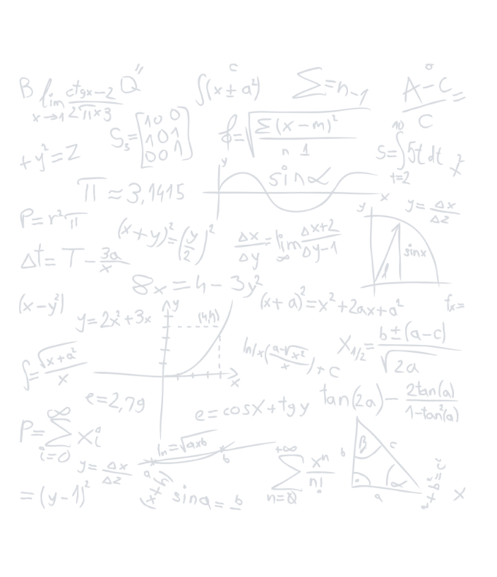
Studying Maths gives us the power to discover and identify essential practical information in our day-to-day lives. For example, it allows us to measure things as distance and speed, and to build anything from a website to a skyscraper. Studying Maths at A-Level will give you a varied skillset that will be indispensable for a variety of tasks.

As technology continues to advance, so too does mathematics, increasing its essential role in both every day and corporate life. New mathematical theories are being discovered and developed every day, enabling inventions and scientific discoveries to continue to flourish. By studying Maths at A-Level, you will have the opportunity to forge a career that’s at the forefront of technological advancement.

Course Content

By studying Maths at A-Level, you’ll develop a number of skills, such as: problem-solving, analytical skills, research skills and logic. Maths allows you to hone your ability to solve mathematical problems as well as abstract and scientific ones too. These problem-solving skills can then be applied to many different areas of your life. You’ll also learn how to analyse patterns, structures and problems, which will in turn, help you to develop a critical eye. This will come in handy in both further study and future careers.

Maths at A-Level will leave you with research skills that will allow you to find solutions to problems, investigate theories, and therefore give you the ability to find new information more effectively. Finally, your logical abilities will be developed so that you will have tools needed to tackle a number of diverse areas, from managing your finances to planning projects.

Topics covered can include:

Pure Maths Year 1: Algebraic Expressions, Quadratics, Equations and Inequalities, Graphs and Transformations, Straight Line Graphs, Circles, Algebraic Methods, Binomial Expression, Trigonometric Ratios, Trigonometric Identities and Equations, Vectors, Differentiation, Integration and Exponentials and Logarithms.

Statistics and Mechanics Year 1: Data Collection, Measures of Location and Spread, Representations of Data, Correlation, Probability, Statistical Distribution, Hypothesis Testing, Modelling in Mechanics, Constant Acceleration, Forces and Motion and Variable Acceleration.

Pure Maths Year 2: Algebraic Methods, Functions, Sequence and Series, Binomial Expansion, Radians, Trigonometric Functions, Trigonometry and Modelling, Parametric Equations, Differentiation, Numerical Methods, Integration and Vectors.
Statistics and Mechanics Year 2: Regression, Correlation and Hypothesis Testing, Conditional Probability, Normal Distribution, Moments, Forces and Friction, Projectiles, Applications of Forces, Further Kinematics.

What other subjects go well with this subject?

Economics, Geography, Philosophy, Chemistry, Physics, Accounts, Information Technology, Biology, Politics etc.

Career Pathway

A-Level Maths is highly valued by Russell Groups and Oxbridge universities. If you’re interested in studying subjects such as Economics, Surveying, Financial Maths, Medicine, Accounting, Data Analysis, Software Development, Physics, or Engineering at university level, then having a strong mathematical education will enhance your enjoyment and performance in these areas of study.

Exam Board

Edexcel

Entry Requirements:

Grade 7 – GCSE Maths (5 GCSE grade 5 or above including English Language)

Cultural Capital Opportunities (Trips, guest speakers, wider enrichment & more)

Working with Wren Engineering and City of London Churches – Heat Mapping in Historic Buildings – using physics and maths for conservation. Maths Challenge and Maths workshops – helping to mentor and support younger students and build leadership skills.

Further Maths

Course Content
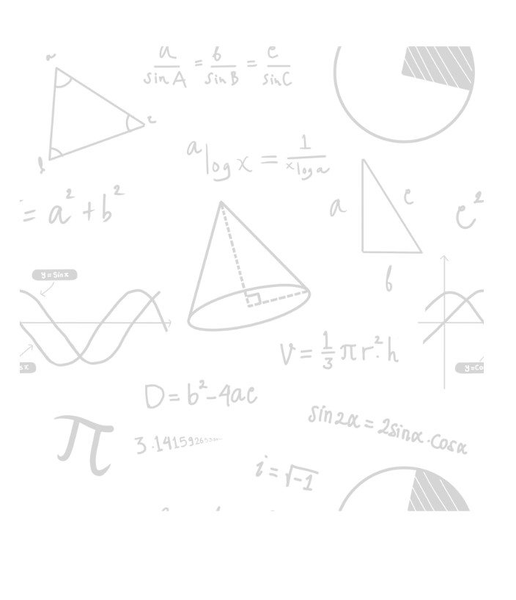
The qualification is both deeper and broader than A level mathematics. A level further mathematics build from GCSE level and A level mathematics. As well as building on algebra and calculus introduced in A level mathematics, the A level further mathematics core content introduces complex numbers and matrices, fundamental mathematical ideas with wide applications in mathematics, engineering, physical sciences and computing. The non-core content includes different options that can enable students to specialise in areas of mathematics that are particularly relevant to their interests and future aspirations. A level further mathematics prepares students for further study and employment in highly mathematical disciplines that require knowledge and understanding of sophisticated mathematical ideas and techniques.

Topics covered can include:

Calculus: Higher level Calculus skills involving complex functions and employing methods such as Integration by parts, by Recognition and by Substitution. Deriving Integrating Factors.
Conic Sections: Understanding eccentricity and derivation of equations of tangents and normal to
Parabolas, Ellipses, and Hyperbolas
Complex Numbers: Finding nth roots of a Complex Number. Application of De Moivre’s Theorem. Solving geometric problems using complex numbers, Problem solving with Maclaurin expansions, series Expansions of Compound Functions.
Further Mechanics: Problem solving using Newton’s Law of Restitution and loss of Kinetic Energy due to Impact, Problem solving involving impacts of smooth spheres with fixed/smooth surfaces.

What other subjects go well with this subject?

Mathematics, Physics, Economics, Computer Science, Business, Chemistry, Biology, Politics.

Career Pathway

Through the study of A-Level Further Mathematics there are many career pathways which are available to students including going onto university to study for a degree in Mathematics, Dentistry, Medicine, Sciences, Engineering, Architecture, Accountancy, Project Management, Actuary, Business Analyst, Data Analyst. This is not an exhaustive list and there are many other financially rewarding career choices which can be made following the completion of the A-Level Further Mathematics qualification. It is worth to mention that only 7 in 100 maths graduates are unemployed 6 months after graduating.

Exam Board
Edexcel

Entry Requirements

Grade 7 in Mathematics

Cultural Capital Opportunities (Trips, guest speakers, wider enrichment & more)

Working with Wren Engineering and City of London Churches – Heat Mapping in Historic Buildings – using physics and maths for conservation. Maths Challenge and Maths workshops – helping to mentor and support younger students and build leadership skills.


Politics

Why study Politics?

Politics A-Level will give you a good understanding of the factors that are driving change all around us and how to make a difference yourself. Unless we understand how the government works, we will never be able to play a full and active part in society. We will always be on the receiving end of other people’s wisdom, rather than being in a position to advance our own agenda. The study of politics takes in grand issues of government and of justice, but also takes you behind these formal facades and seeks to understand the crucial questions of where power lies and helps you to understand ‘who gets what, how and why’.

Course Content

A Level Politics gives you an understanding of the workings of the British political system, an in-depth analysis of political ideologies and global politics including international relations. You will explore the extent to which governance in the UK is democratic, what is freedom, how is it best promoted and protected and question whether or not we even need a government at all.

You will look why should we be governed, what is democracy and how close does the UK political system come to meeting this ideal. These are some of the concepts we will discuss that will enable you to develop an in-depth understanding of British politics. We will explore the political ideas associated with liberalism, conservatism, and socialism and the extent to which these can be found within the parties competing for our votes. In year two we focus on the politics of the United States of America covering the same related content as year one.

Topics covered can include:

UK Politics:
- Democracy and participation: Political parties; Electoral systems; Voting behaviour and the media
- Conservatism, liberalism, socialism
UK Government:
- The constitution; Parliament; Prime Minister and executive; Relationships between the branches; nationalism
Comparative Politics:
- US Government; The US Constitution; The US Congress; The US Presidency; The US Supreme Court; US Politics; Elections; Political Parties; US pressure and advocacy groups

What other subjects go well with this subject?

Economics, English Literature, English Language, Ethics, Philosophy & Religion Modern Foreign Languages, Geography, History, Law, Philosophy, Psychology, and Sociology.

Career Pathway
A level politics is highly valued by Russell Groups and Oxbridge universities. Typical careers which can follow studying Politics are as follows: National and local government and public service, civil service, banking and accounting, law, television and radio broadcasting, publishing and management consultancy to name a few.

Exam Board

Edexcel

Entry Requirements

Grade 5 (Eng Language, History, Sociology, Geography)

Cultural Capital Opportunities (Trips, guest speakers, wider enrichment & more)

Westminster – Parliament visits and visits to the House of Commons/Lords & Supreme Court; Politics revision workshops and guest speakers. Opportunities to run debate club and mentor younger students in how important having a political voice is!

Physics


Why study Physics?

The main reason to studying Physics is that it will give you incredibly strong analysis and problem-solving skills. It will develop your mathematical skills, but also your literacy, and combine both together to give you the skills you need in many challenging careers. You may plan to become a Physicist, using your skills to improve humanity’s understanding of our world and universe. You might become an engineer, at the smallest or largest scales, improving the world around us with aeroplanes or microbes. Closely related, those of an artistic mindset might design buildings and even skyscrapers as architects. You might step sideways into finance, using your maths skills better than any economics student to create trading algorithms. Perhaps your expertise in problem-solving is what will make you an exceptional doctor instead of an average one?

Course Content

We study OCR Physics A at St Augustine’s, which organises the course into traditional content-based units and chapters, such as Module 5, Newtonian Physics, which includes but is not limited to chapters on Circular Motion and Gravitational Fields, but the strength of the course is that there are many opportunities for linking skills developed in one area to those in others. The ability to develop from someone who knows about series and parallel circuits into a learner who can use that knowledge to build their own understanding of, say, capacitors and integrate that with a framework for electric fields is what makes the course special. As well as developing your mathematical skills and literacy, you will become skilled at both interpreting diagrams and creating your own to communicate your ideas to others. As with all sciences, you will undertake a practical endorsement, and we make sure to cover more practical work than the minimum required by the exam board. This covers such elements as the use of light gates, lasers and radioactive materials.

Topics covered can include:

Forces and motion: Motion, forces, work/energy/power, materials and momentum
Electrons, waves and photons: Charge and current, potential difference and resistance, waves and quantum physics
Newtonian world and astrophysics: Thermal physics, oscillations, gravitational fields and cosmology
Particles and medical physics: Electrical and magnetic fields, particle physics, nuclear physics and medical imaging

What other subjects go well with this subject?

Physics is both a literate and numerate subject, so goes well with a wide range of subjects. Of particular relevance is maths, as there is a lot of crossover. Many students aiming for medicine combine it with other sciences. Ultimately though, anyone can combine Physics with their other chosen subjects if they have the skills and enthusiasm needed.

Career Pathway

Physics is regarded as one of the most challenging A-Levels and is therefore highly valued by Russell Groups and Oxbridge universities. Typical careers which can follow studying Politics are as follows: Research, Engineering, Architecture, Finance and Medicine.

Exam Board

OCR (We follow the ‘A’ specification, but use ideas from the ‘B’ specification to give a richer overall experience.)

Entry Requirements

Grade 7 in Maths and Grade 6 in Physics OR a grade 7 in Combined Science.

Cultural Capital Opportunities (Trips, guest speakers, wider enrichment & more)

Working with Wren Engineering and City of London Churches – Heat Mapping in Historic Buildings – using physics and maths for conservation. Maths Challenge and Maths workshops – helping to mentor and support younger students and build leadership skills.

Psychology

Why study Psychology?


Psychology delves into the complexities of the human mind, examining behaviour, cognition, and emotions. Studying psychology opens doors to many different career opportunities. From clinical psychologists providing therapeutic support, to industrial-organisational psychologists shaping workplace dynamics, this subject offers the chance for understanding and improving all kinds of aspects of human life. Psychology is also transferable to other exciting careers such as marketing, human resources, and healthcare, making it a versatile foundation for personal and professional growth. Whether you choose to pursue counselling, research, or organisational development, a background in psychology gives you valuable insights into human behaviour and the skills to make a positive impact on both individuals and communities.

Course Content

This qualification offers an engaging and effective introduction to Psychology. Students will learn the fundamentals of the subject and develop skills valued by Higher Education (HE) and employers, including critical analysis, independent thinking and research.

Topics include:

Social influence, Memory, Attachment, Approaches, Research Methods, Psychopathology, Schizophrenia, Relationships and Forensics.

What other subjects go well with this subject?

Economics, English Literature, English Language, Ethics, Philosophy & Religion Modern Foreign Languages, Geography, History, Law, Philosophy, Psychology, and Sociology.

Career Pathway

Psychology builds on skills developed in the sciences and humanities, and enables progression into a wide range of other subjects in HE. Students have the opportunity to learn how to analyse arguments and evidence, test hypotheses and make informed judgements – all skills valued by Higher Education institutions and employers.
Studying psychology at university can give you a whole host of exciting career options, including: Marketing, Business development, Advertising, Human resources, Forensic psychology, Occupational therapy, Clinical psychology, Nursing, Counselling, Teaching, Educational Psychology and Sports Psychology.

Exam Board

AQA

Entry Requirements

Grade 5 (Sociology, RS or other relevant Humanities qualifications)
Grade 5 (Eng Language/Literature/Sciences)

Cultural Capital Opportunities (Trips, guest speakers, wider enrichment & more)

Helping to mentor and support younger students and build leadership skills.

RS (Philosophy and Ethics)

Why study RS?


RS A Level is a challenging, stimulating, and thought-provoking subject. The course trains you how to write fluently, and how to develop concise and coherent arguments. You will also be able to explain, analyse and evaluate complex ideas and theories, and to link ideas together. By the end of the course, you will be able to think analytically, critically, and logically. These are extremely valuable skills that can be transferred to any field of study or job.

Course Content

It’s an extremely interesting and enjoyable subject. In RS A Level, you get to discuss some pretty big, all-encompassing questions. You will be asking and trying to answer questions like ‘what caused the universe?’
There are three main topics in the A Level
Philosophy, which is about asking questions about what is real.
Ethics, which is about asking questions about how we should behave
Christianity, which is about asking questions about religion, and whether religion is relevant in the modern age

Topics covered can include:

Component 1: A Study of Religion - Written examination: 2 hours - 33⅓% of qualification
Topics covered include: Who was Jesus? Does God have a gender? Can God suffer?
Why were some books accepted in the Bible and not others?

Component 2: Philosophy of Religion - Written examination: 2 hours - 33⅓% of qualification
Topics covered include: Is the world evidence for God’s existence or are we here purely by luck and chance? Is religion just a drug? Is religion just a childish thing to make us feel better about our lives? In RS you get to study the ideas of many famous philosophers such as Aristotle, Plato, Karl Marx and Freud.

Component 3: Religion and Ethics - Written examination: 2 hours -33⅓% of qualification
Topics covered include; Do moral laws come from God or from our own minds?
What is more important, duty or consequences? Is it okay to break moral laws sometimes to get the best outcome?

What other subjects go well with this subject?

Any subject at all, but especially, English Literature, English Language, Psychology, History, Sociology, Science or Maths

Career Pathway

RS A Level is highly respected by universities. People who have studied RS have gone on to complete degrees in a wide range of subjects.
Exam Board

EDUQAS

Entry Requirements

Grade 5 (RS, other relevant Humanities qualifications)
Grade 5 (Eng Language/Literature)

Cultural Capital Opportunities (Trips, guest speakers, wider enrichment & more)

RS Drop Down Days as part of the wider enrichment programme and PSHE for Sixth Form – debates on philosophy and ethics; how to make a difference in the world by learning how to listen, engage, understand and ‘disagree agreeably.’

Sociology

Why study Sociology?


Studying sociology is a valuable experience that can provide great insight into our society and the way it operates. It's a fascinating field of study that explores the relationships between individuals and groups, as well as the structures and cultures that shape our lives. By learning about sociology, we can better understand the complexities of our society, become more aware of our own beliefs and biases, and gain a better understanding of how social systems, organisations, and institutions work.

Course Content

Human beings are social creatures and sociology helps you to make sense of the world. Sociology students will explore human behaviour as it relates to social interaction with individuals, social groups, and social institutions (e.g. the family, the workplace etc.)

Year 1
- Socialisation, culture and identity
- Families and relationships
- Research methods that allow for the understanding of social inequality relating to social class, gender, ethnicity and age
- Understanding social inequalities relating to social class, gender, ethnicity and age

Year 2
- Globalisation and the digital world
- Crime and deviance

What other subjects go well with this subject?

Economics, English Literature, English Language, Ethics, Philosophy & Religion Modern Foreign Languages, Geography, History, Law, Philosophy, Psychology, and Sociology.

Career Pathway

RS A Level is highly respected by universities. People who have studied RS have gone on to complete degrees in a wide range of subjects.

Exam Board

OCR

Entry Requirements

Grade 5 (Sociology or other relevant Humanities qualifications)
Grade 5 (Eng Language/Literature)

Cultural Capital Opportunities (Trips, guest speakers, wider enrichment & more)

Helping to mentor and support younger students and build leadership skills.

Level 3 Sport

Why study BTEC Sport L3?


The BTEC Sport is designed to have a mixture of exam and coursework (controlled assessment) elements and may suit those who prefer to work methodically through coursework with fewer exams. Students have an opportunity to sit the January series of exams in Year 13 and complete the exam units early or re-sit in the summer series so provides flexibility compared to A-Level courses. The BTEC Sport is tailored for our students and contains units that compliment other popular A-Levels studied at the school and has expert teaching from a high performing department. This course is perfect for those who have a real interest in sport and how our body works. There is no need to be a regular performer in sport as there is no assessed practical element.

Course Content

BTEC sport gives students the opportunity to study many aspects of sport and the human body and relate this knowledge to sporting examples. The anatomy and physiology unit links well with those studying biology and will look in depth at the responses to exercise on the human body. Students will learn how to tailor and design training programmes for athletes, including identifying nutritional and health key indicators for living healthy, active lifestyles. The course also prepares students for getting their first jobs in the sports industry by taking students through the whole application process from conducting SWOT analysis, writing a CV and application to interview techniques.

Sport psychology will use well-known theorists to explain why different performers mat respond in different ways in sport and how we can support athletes to control their psychology to optimise performance. The concepts learnt in this unit cross over well with psychology A-Level courses.

Topics covered can include:

Unit 1: Anatomy and Physiology (Exam)
Unit 2: Fitness Training and Programming for Health and Well-being (Exam)
Unit 3 : Professional Development in the Sports Industry (Controlled Assessment)
Unit 6: Sport Psychology (Controlled Assessment)

What other subjects go well with this subject?

Biology, Psychology, and Sociology.

Career Pathway

The qualification carries UCAS points and is recognised by higher education providers as meeting requirements for many relevant courses. Learners can progress to higher education on full degree single or combined courses, for example:
• BSc(Hons)Sports Management
• BSc(Hons)Sports Business Management
• BSc(Hons)Sports Science
• BSc(Hons)in Sport and Exercise Psychology
The course can also lead to many vocational careers in sport such as personal training, leisure centre management and sports coaching.

Exam Board

Edexcel (Pearson)

Entry Requirements

Five Grade 5 (including Maths and English), Grade 5 (Science) preferably.

Cultural Capital Opportunities (Trips, guest speakers, wider enrichment & more)

Helping to mentor and support younger students and build leadership skills in primary school and in KS3; supporting PE lessons and the promotion of Sport across the school. Visit to Brunel University Sports Science department looking specifically at careers in healthcare such as physiotherapy.

St Augustine’s Sixth Form - Course Requirements
Subject | English | Maths | Relevant Subject | Additional requirements
AAQ Applied Science | 5 | 5 |  | GCSE combined Science - Grade 5 6 Minimum, GCSE separate Science 5 5 5 Minimum
Sport | 5 | 4 |  | 3 other subjects graded 9-5
IT – Data Analytics | 5 | 4 |  | 3 other subjects graded 9-5
Cambridge Technical Business Studies | 5 | 4 | 4 in Business | 3 other subjects graded 9-5
Fine Art | 5 |  | 5 in Art or Graphics | 5 dependents on department approval
Biology | 6 | 6 | See Additional requirements | Double award Minimum 7 in Biology/Triple Award Minimum 6 in Biology
Chemistry | 6 | 6 | See Additional requirements | Double award Minimum 7 in Chemistry/Triple Award Minimum 6 in Chemistry
French | 5 | 5 | 6 GCSE French and or Spanish
Physics | 6 | 7 | See Additional requirements | Double award Minimum 7 in Physics/Triple Award Minimum 6 in Physics
English Literature | 5 | 5 | 5 in English Literature
Maths |  | 7
Further Maths |  | 8 |  | Must also be doing Maths A Level
Politics | 5 | 5 | 5 History, Sociology | Extended Writing Subject
History | 5 | 5 | 5 in History | Extended Writing Subject
Graphics | 5 | 5 | 6 in Graphics
Psychology | 5 | 5 | 5 in Psychology | 5 in Sciences
Religious Studies | 5 | 5 | 5 in Religious Studies
Sociology | 5 | 5 | or 5 in History/Religious Studies
Business Studies | 5 | 5 | 5 in Business Studies

**The requirements provided are a guide – Entry will be subject to department and Senior leadership discretion**

