**TABLE TENNIS**

**Worksheet**

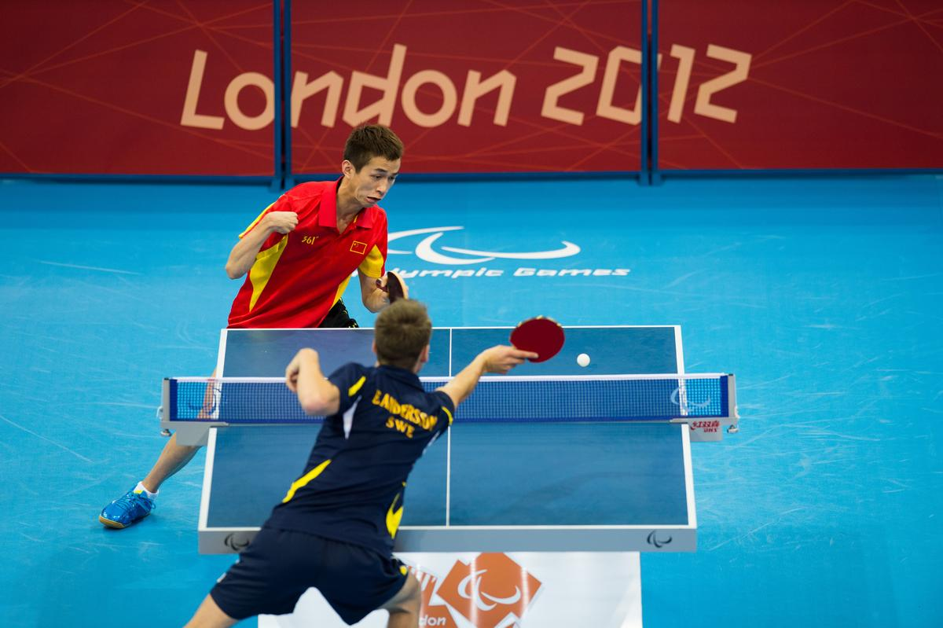

**Name:**

**Form:**

**THE RULES OF TABLE TENNIS**



* Table tennis is played on a rectangular table. There is a low net across the middle of the table which divides it into two courts.
* Players stand at each end of the table.
* When the game is between two players, it’s called ‘singles’. If there are four players, it’s called ‘doubles’.
* The players hit a small, light ball to each other. They hit the ball with rackets made of wood covered with rubber. The rackets can be any shape, weight or size, but they must be made of wood and rubber.
* To start the game, one player hits or ‘serves’ the ball. The other player tries to hit the ball back (or ‘returns the serve’).
* The ball must go over the net and land on the opposite court.
* When players hit the ball to each other, it’s called a ‘rally’. The rally continues until a player misses the ball, hits it into the net, or off the table.
* The aim of the game is to hit the ball so that the other player misses it.
* Singles matches are played over the best of seven games. The first player to reach 11 points wins each game provided there is a margin of two points.
* Team matches are played to the best of five games.

**1-MATCH THE WORDS IN THE TABLE WITH THEIR DEFINITIONS BELOW.**

|  |  |  |  |
| --- | --- | --- | --- |
| Doubles | Net | Racket | Rally |
| Serve | Singles | Table |  |

1. A continuous exchange of hits between players.

2. Games played between two players.

3. Games played between four players.

4. The area where the game is played.

5. The rectangular piece of material made from string which separates the two courts. In table tennis it is 15.25 centimetres high.

6. To hit the ball to the other player as a way of starting the game.

7. What the players use to hit the ball.



**QUESTIONS AND ANSWERS**

**Table Tennis? Why play tennis on your table?**

Well, at first, people did both. Table tennis began as an after-dinner game in England in

the 1870s.

**What did people use for a net?**

At first they stood a row of books across the middle of the table.

**And the racket and ball?**

One story says that they used books to hit a golf ball from one end of the table to the

other.

**That can’t have been good for the table - or the china.**

True - I think they cleared the table before they started the game.

**Any other stories about how Table Tennis began?**

Yes, another story says they used cigar boxes as rackets and champagne corks as balls.

**So it was an upper-class game for drinkers and smokers?**

That’s how it started. But now it’s the most popular game in the world.

**Really! How did that happen?**

Well, they began making wooden rackets in 1901 and they introduced the celluloid ball.

Then they added a rubber surface to the racket - that meant you could spin the ball, so

the game became more interesting.

**And you didn’t need to open the champagne each time you wanted to play?**

Correct.

**Is table tennis the same as Ping Pong?**

Yes - it also used to be called Wiff Waff and Flim Flam - because of the sound the ball

makes as you hit it.

**So when did it become an international sport?**

The first World Championships were in London in 1926. Then it was included in the 1988

Olympics. Since then, China has won 20 of the 24 possible gold medals. In the 2008

Games, the Chinese beat every other player in the Games - they wiped the floor with

them!

1. **WHICH PHRASE DOES EACH OF THE NUMBERS REFER TO?**

1. What was the other name for Table

Tennis?

a. Pong Pong

b. Ping Ping

c. Pong Ping

d. Ping Pong

2. What was used as a ball?

a. a champagne bottle

b. a champagne cork

c. a cigar box

d. a cigar

3. When was Table Tennis first played?

a. the 1780s

b. the 1980s

c. the 1890s

d. the 1870s

4. What time of day was it first played?

a. during dinner

b. before dinner

c. anytime

d. after dinner

5. Table Tennis became popular when:

a. wooden rackets were made

b. champagne became cheaper

c. it became an international sport

d. it was too rainy to play tennis outside

6. Table Tennis became an Olympic

sport in:

a. 1926

b. 1988

c. 1901

d. 2008



**3-FILL DE GAPS**

|  |  |  |  |
| --- | --- | --- | --- |
| won | used | began | included |
| wiped | became | stood | meant |

1. Table tennis __________ as an after-dinner game.

2. They __________ a row of books across the middle of the table.

3. They __________ cigar boxes as rackets.

4. A rubber surface __________ you could spin the ball.

5. The game __________ more interesting.

6. Table tennis was __________ in the 1988 Olympics.

7. China has __________ 20 of the 24 possible gold medals.

8. In the 2008 Games, the Chinese __________ the floor with their opponents.

**4-ANSWER THE QUESTIONS**

**4.1 Prepare a Warm Up Pre-Match**

# **4.2 Here we got the Link of the “**Men's Table Tennis Singles Gold Medal Match - China v China | London 2012 Olympics”

<https://www.youtube.com/watch?v=yiqFxDx2WW4>

.Indentify the second/minute when one of the players takes the next shots:

* Forehand Drive
* Backhand Drive
* Forehand Push
* Backhand Push
* Forehand Serve
* Backhand Serve