**FOOTBALL**

**Worksheet**



**Name:**

**Form:**

**1-VOCABULARY**

1. Write the correct words in the spaces provided.

|  |  |  |  |
| --- | --- | --- | --- |
| A Header | B Red card/ Yellow card | C Throw-in | D Pitch |
| E Goalkeeper | F Save | G Referee |  |

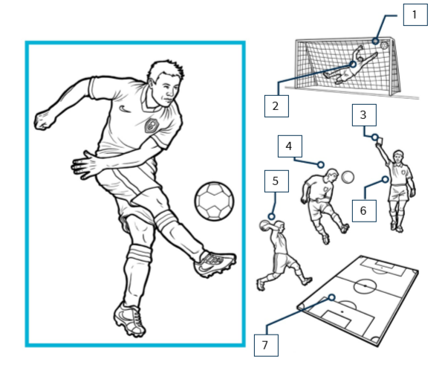

**The rules of football**

* Two teams of 11 players play on a pitch. Each team tries to score more goals than the other.
* A game lasts 90 minutes, divided into two 45-minute halves.
* Players can use any part of their body except their arms and hands to move the ball. The exception is when a player takes a throw-in.
* Goalkeepers can use their hands, especially when making a save.
* If a player commits a foul, then a free kick is awarded to the other team.
* If there is a foul inside the penalty area, a penalty kick is awarded to the other team.
* If there is a more serious foul such as a bad tackle or handball, the referee can show a yellow or red card. Two yellow cards or one red card mean a player is expelled from the game.
* If teams have the same score (a draw) then extra time and penalty shootouts are used to decide the winner.
* In Olympic football male players must be under 23 years old, though they can have three older players in each team. There are no age restrictions for female players.



**2-MATCH THE WORDS IN THE TABLE WITH THEIR DEFINITIONS BELOW**

|  |  |  |  |  |
| --- | --- | --- | --- | --- |
| Foul | Free kick | Goalkeeper | Handball | Pitch |
| Referee | Save | score | tackle | Throw-in |

1. An attempt to take the ball from a player in the other team

2. An opportunity to kick the ball without opposition from the other team

3. Get a goal

4. Something against the rules

5. Stop the ball from going into the goal

6. The act of throwing the ball from the sideline after the ball has gone out of play

7. The area of grass where the game is played

8. The person who is in charge of the game and who makes sure that the rules are followed

9. The player who stands in the team's goal to try to stop the other team from scoring

10. When a player intentionally touches the ball with their hand or arm

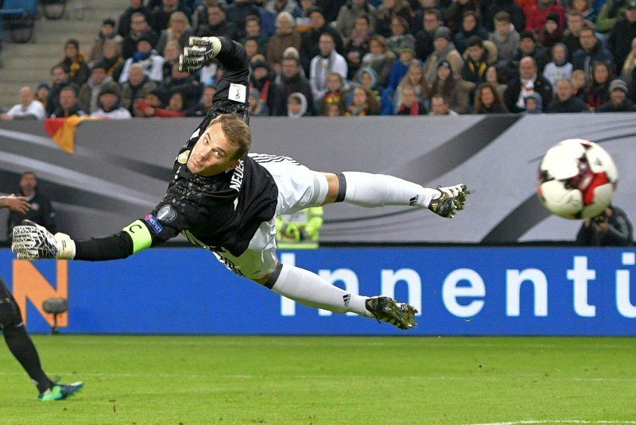

**Questions & Answers**

**Olympic Games Football**

**There’s football at the Olympics? You don’t hear much about it. I mean, it’s not like the World Cup, is it?** You’re right – the World Cup is definitely the biggest prize in football, but the sport has a long Olympic history, too.

**You’re not going to tell me the ancient Greeks played, are you?** No, but football has been on the Olympic programme since 1900. And women’s football since 1996. In comparison, the first World Cup only took place in 1930.

**Ok, but I suppose the same teams always win: Brazil, Italy, Germany …** Actually no. Italy’s won once and Germany (the old German Democratic Republic) once also, Argentina won 2 times.

**Really? So who’s won all the medals?** Hungary, the former Yugoslavia and the former Soviet Union have each won five medals in the men’s competition and the USA women three golds.

**Which players play at the Olympic games?** Since 1992 male footballers have to be under 23 years old, though they can have three older players in each team. But you still get to see some real stars – in Beijing 2008 Messi and Ronaldinho both played.

**.Glossary:**

**-The World Cup:** An international football competition held every four years and organised by the Fédération Internationale de Football Association (FIFA).

**-Off-side rule:** A law in football which states that a player cannot be actively involved in the play if he is closer to the opponent's goal line than both the ball and the second-to-last defender when the ball is touched or played by a teammate.

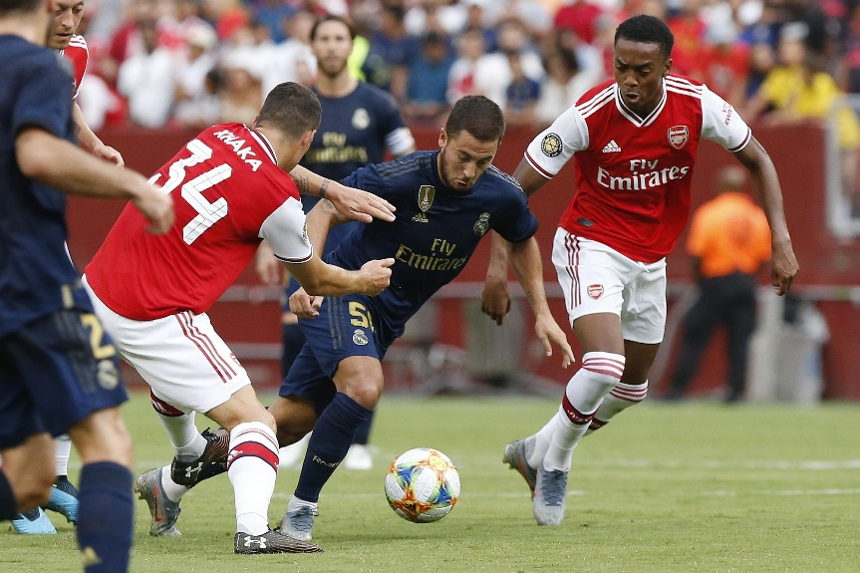

**3-DECIDE IF THE FOLLOWING STATEMENTS ABOUT THE TEXT ARE TRUE OR FALSE**

1. The World Cup is a more important football competition than the Olympics.
2. Football was played at the ancient Olympics.
3. European teams have won more medals than other countries in the men’s competition.
4. Messi and Ronaldinho both played at 2008 the London Olympics.
5. Football is an U23 competition??? At the Olympics.
6. The off-side rule is complicated.



**4-ANSWER THE QUESTIONS (google them)**

1. Which Premier League winner’s father played rugby for Wales?
2. What year did the Premier League start?
3. Who was the first sponsor of the Premier League?
4. In what season did Roman Abramovich take over Chelsea?
5. Give me a list of Derbies of the English football.
6. Which player has scored more goals in the Premier League?
7. Which player holds the record for most consecutive Premier League appearances ?
8. Which team have won more FA Cups?
9. Who scored the first ‘perfect hat-trick’ (left foot, right foot, and header) in the Premier League?
10. What player scored four goals in 12 minutes after coming on as a sub versus Nottingham Forest?
11. Give me your best “Formation” and explain why *(The****formation****describes how the players in a team generally position themselves on the*[*pitch*](https://en.wikipedia.org/wiki/Association_football_pitch)*)*

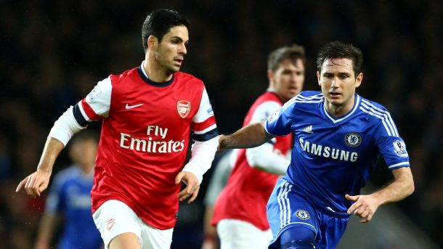

**5-FIND THE DEFINITIONS AND GIVE SOME INFORMATION (Google it) OF EACH ONE:**

**1.Ball Control**

**2.Dribbling**

**3.Passing accuracy**

**4.Body Control**

**5.Spatial Awareness**

**6. Tactical Knowledge**

**7.Shooting**