

Name:_________________

Form:__________________  
Teacher:________________

ATHLETICS

**Challenge 1:**

Identify as many different athletics events as you can in the space below.

**Challenge 2:**

State the different events that make up the women’s pentathlon.

**Challenge 3:**

State the different events that make up the men’s heptathlon.

**Sprint: 100m**

1. Design an effective warm up for an athlete who is about to compete in a 100m sprint.   
   Think about the different phases of a warm up and the skills & drills we looked at during our lessons.

**Warm up:**

1. Identify different coaching points when completing the 100m sprint.

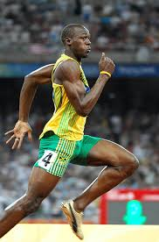

**Coaching points:**

1. Explain why the 100m sprint is anaerobic **or** aerobic form of exercise.

**Middle Distance: 400m**

4. Using the **key** above, split the 400m sprint into four different phases and discuss tactics/strategies to help you complete the race.

**4**

**3**

**2**

**1**

**Key:**

* Phase 1
* Phase 2
* Phase 3
* Phase 4

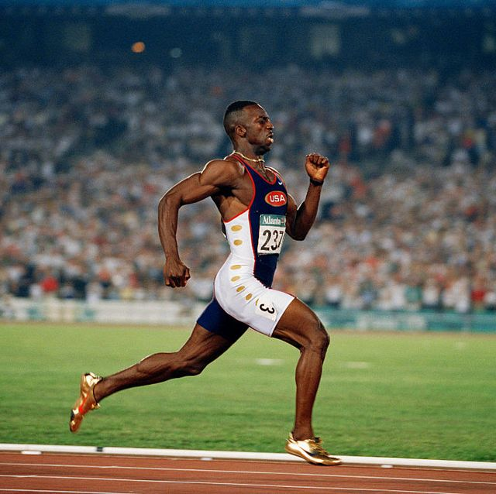 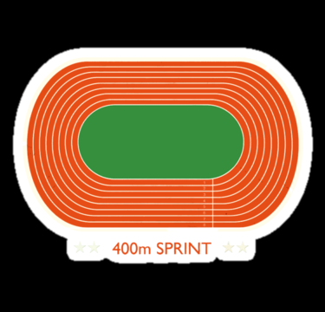

**Long Distance: 800/1500m**

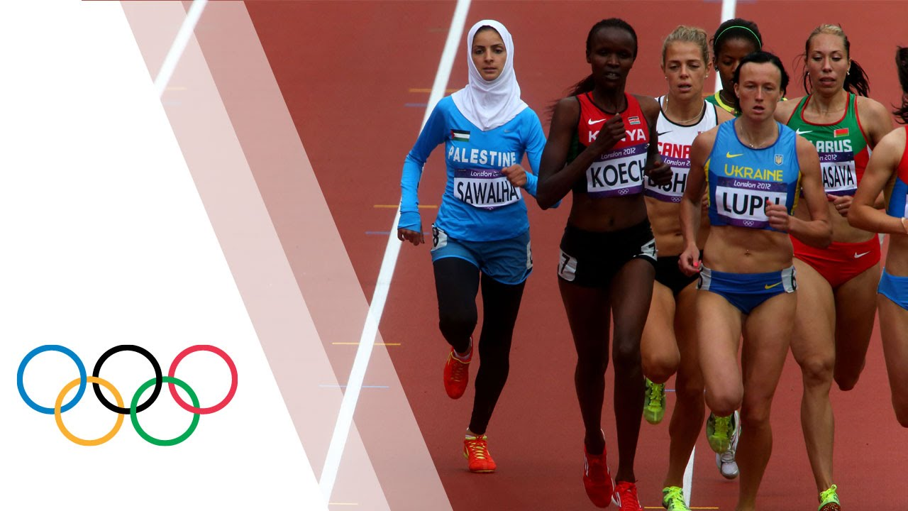

5. Explain why pacing is important when completing 800/1500m.

6. Identify and define the method of training used when completing the 800m/.

**Throw: Discus**

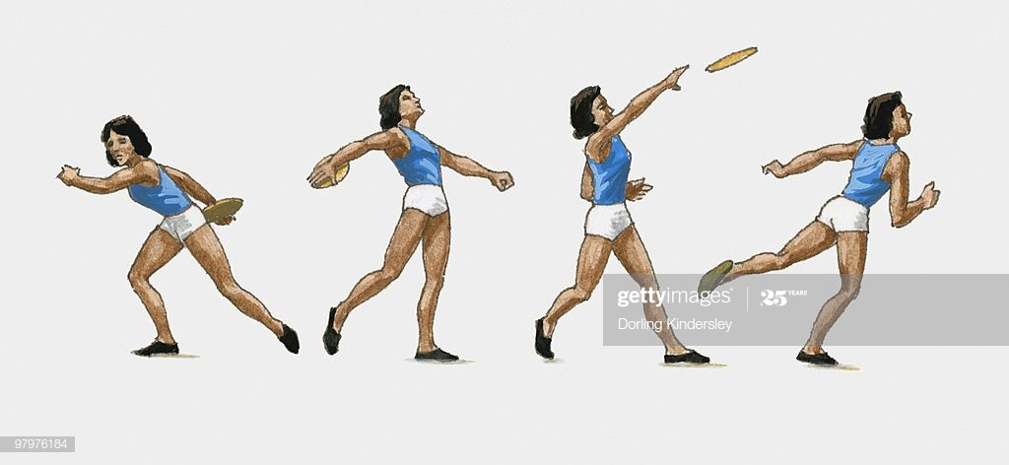

7. Outline the coaching points for each phase from the image above.

**Key Words:**

* Grip
* Starting position
* Preparation phase
* Chin
* Knee
* Toe
* Throwing technique
* Release

**Jump: Long Jump**

8. Design an effective activity which will help an athlete improve their take off phase during long jump.

